Ideation Phase
Empathize & Discover

Date | 9 July 2026
Team ID
Project Name | ShopEZ
Maximum Marks | 4 Marks

Empathy Map Canvas: 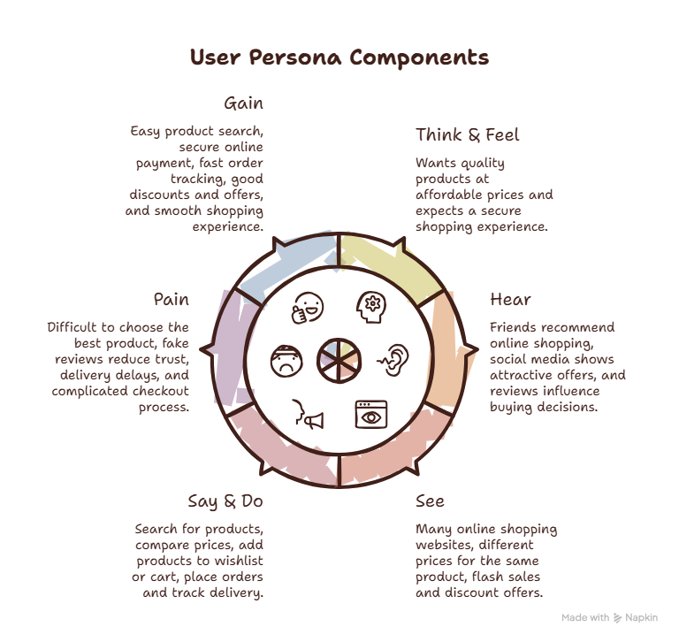

Customer Flow
Home
│
▼
Register / Login
│
▼
Browse Products
│
▼
Search / Filter
│
▼
Product Details
│
▼
Add to Cart / Wishlist
│
▼
Checkout
│
▼
Payment
│
▼
Order Confirmation
│
▼
Track Order

Seller Flow
Seller Login
│
▼
Seller Dashboard
│
▼
Manage Products
│
▼
Manage Inventory
│
▼
View Orders

Delivery Manager Flow
Login
│
▼
Assigned Orders
│
▼
Update Delivery Status
│
▼
Order Delivered

Admin Flow
Admin Login
│
▼
Dashboard
│
┌───┼───────────┐
│ │ │
▼ ▼ ▼
Users Categories Orders
│
▼
Support Tickets

Conclusion
The empathy map helped us understand the needs and expectations of online shoppers. Based on these insights, ShopEZ was designed to provide secure shopping, simple navigation, multiple payment options, order tracking, and role-based services to improve the overall user experience.

